FRANCOIS MERCER

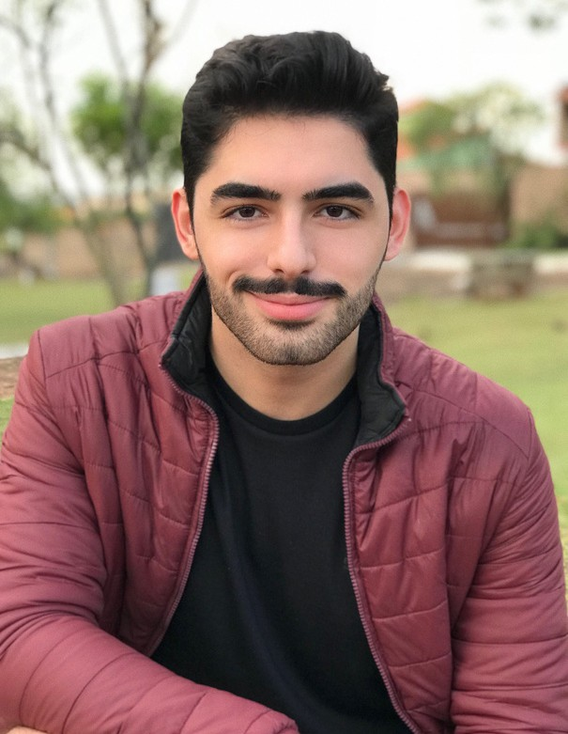

**CONTACT**

123-456-7890

[hello@reallygreatsite.com](mailto:hello@reallygreatsite.com) reallygreatsite.com

B A C K E N D E N G I N E E R

# ABOUT ME

I’m a professional back end engineer who has been working in the industry for over 3 years. I deal with complex issues efficiently.

# EDUCATION

Borcelle University | 2014-2018 **Bachelor’s Computer Engineering** GPA : 3.5

# EXPERIENCES

**PROFESSIONAL SKILLS**

Analytical & problem solving skills

Communication team

Ability to work in multiple projects

Others

84%

85%

95%

90%

Back End Engineer | 2018-2019

## Fauget

 Generate recyclable code libraries

 Implement ongoing security systems

 Attend regular meetings with the front end team to expose weaknesses and problems

 Routinely inspect server code for speed optimization

Back End Engineer | 2020-now

## Arowwai Industries

 Configure usability of all front side applications

 Maintain a stable server with zero downtime

 Keep a backup library before any large changes to server